Trisia Baltazar

A2

1. A publisher publishes at least one or many books.

A book is published by one and only one publisher.

A publisher submits at least one or many contracts.

A contract is submitted by one and only one publisher.

An author signs at least one or many contracts.

A contract is signed by one and only one author.

An author writes at least one or many books.

A book is written by one and only one author.

1. 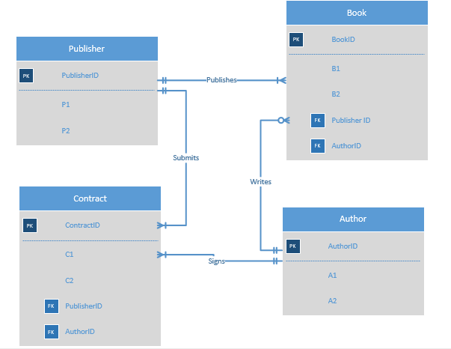
2. The first four tables show the basic, individual tables.

|  |  |
| --- | --- |
| **Publisher** | |
| **Publisher ID** | **Publisher Name** |
| P1 | XxX |
| P2 | YyY |
| P3 | ZzZ |

|  |  |
| --- | --- |
| **Book** | |
| **Book ID** | **Book Title** |
| B1 | A Game of Thrones |
| B2 | Hunger Games |
| B3 | Othello |
| B4 | The Winds of Winter |

|  |  |
| --- | --- |
| **Author** | |
| **Author ID** | **Author Name** |
| A1 | George R.R. Martin |
| A2 | Adam Smith |
| A3 | Suzanne Collins |

|  |  |
| --- | --- |
| **Contract** | |
| **Contract ID** | **Contract Name** |
| C1 | Be-2 |
| C2 | Me-41 |
| C3 | Ge-99 |
| C4 | Te-63 |

The following tables show the relationships and are based on the business rules.

|  |  |
| --- | --- |
| **Book and Publisher** | |
| **Book ID** | **Publisher ID** |
| B1 | P1 |
| B2 | P2 |
| B3 | P2 |
| B4 | P3 |

|  |  |
| --- | --- |
| **Publisher and Contract** | |
| **Publisher ID** | **Contract ID** |
| P1 | C1 |
| P2 | C2 |
| P2 | C3 |
| P3 | C4 |

|  |  |
| --- | --- |
| **Author and Contract** | |
| **Author ID** | **Contract ID** |
| A1 | C1 |
| A2 | C2 |
| A3 | C3 |
| A3 | C4 |

|  |  |
| --- | --- |
| **Author and Book** | |
| **Author ID** | **Book ID** |
| A1 | B1 |
| A1 | B4 |
| A2 | B2 |
| A3 | B3 |